PROJECT BASED LEARNING

GROUP-6

* SANCHIT JAIN -21103192
* DEVANSH AGARWAL -21103194

**ROUTER**

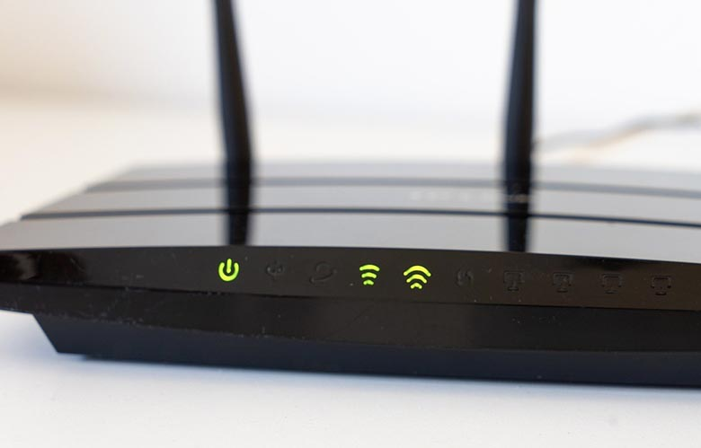

**What Are Routers?**

If u had a telecom company which has one branch office in Bangalore and another in Hyderabad, then to establish a connection between them we use routers at both ends which were connected through fiber optic cable through high bandwidth STM links or DS3 links.

By this scenario, the traffic in the form of data, voice or video will flow from both ends dedicatedly between them without the interference of any third unwanted traffic. This process is cost-effective and time-efficient.

**FEATURES OF ROUTER**

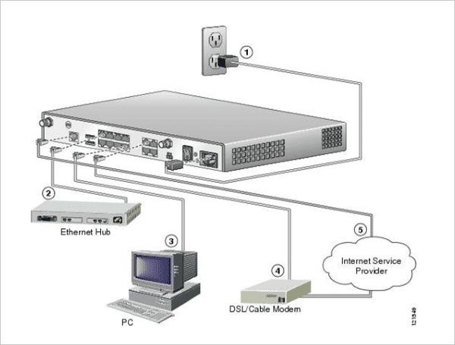

* Works on the network layer of the OSI reference model and communicate with neighbor devices on the concept of IP addressing and subnetting.
* The main components of routers are the central processing unit (CPU), flash memory, non-volatile RAM, RAM, network interface card, and console.
* Routers have a different kind of multiple ports like fast-Ethernet port, gigabit, and STM link port. All ports support high-speed network connectivity.
* Depending upon the type of port needed in the network the user can configure them accordingly.
* Routers carry out the data encapsulation and decapsulation process to filter out the unwanted interference.
* Routers have the inbuilt intelligence to route traffic in a big networking system by treating the sub-networks as an intact network. They have the capability to analyze the type of next link and hop connected with it which makes them superior to other layer-3 devices such as switch and bridges.
* Routers always work in master and slave mode thus provides redundancy. Both routers will have the same configurations at the software and hardware level if the master fails then the slave will act as Master and perform its entire tasks. Thus saves the complete network failure.

**WORKING**

**The working is divided into two different planes,**

* **Control plane**: The routers maintain the routing table which stores all the static and dynamic routes to be used to destine the data packet to the remote host. The control plane is a logic which fabricates a forwarding information base (FIB) to be utilized by forwarding plane and also it has the information regarding the physical interface the routers to be connected.
* **Forwarding Plane**: based on the information it gathers from the control plane based on records in routing tables it forwards the data packet to correct remote network host. It also takes care of correct inward and outward physical connections.
* **Forwarding**: As we know that the main purpose of routers is to connect big networks such as WAN networks. As it works on layer-3 so it takes the forwarding decision on the basis of the destination IP address and subnet mask stored in a packet directed for the remote network.

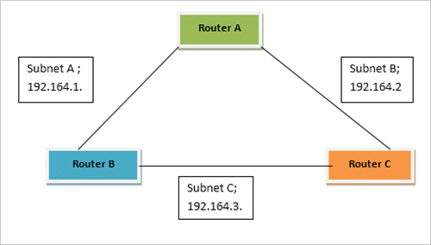

* As per the figure, Router A can reach out the Router C via two paths, one is directly through Subnet B and another is through Router B using Subnet A and Subnet C respectively. In this way, the network has become redundant.
* When a packet arrives at router it first lookout in the routing table to find the best-suited path to reach the destination and once it gets the IP address of next hop it encapsulates the data packet. To find out the best path routing protocol is used.
* The route is learned by gathering information from the header associated with each of data packet arrives at each node. The header contains the IP address information of the next hop of the destination network.
* To reach a destination, several paths are mentioned in the routing table; by using a mentioned algorithm it uses the best suitable path to forward data.
* It also checks that the interface on which packet is ready to be forward is accessible or not. Once it collects all the necessary information then it sends the packet according to the route decided.
* The router also supervises the congestion when packets reach any hope of the network at a pace greater than the router is able to process. The procedures used are a tail drop, random early detection (RED) and weighted random early detection (WRED).
* The idea behind these is router drop the data packet when the size of the queue is exceeded what is predefined during configuration and can be stored in buffers. Thus the router discards the newly arrived incoming packets.
* Apart from this router takes the decision of choosing which packet to be forwarded first or at what number when several queues exist. This is implemented by QoS (quality of service) parameter.
* Performing policy-based routing is also a function of Routers. This is done by bypassing all the rules and routes defined in the routing table and making a new set of rules, to forward data packet on an immediate basis or on priority. This is done on the requirement basis.
* By performing the various tasks within the router the CPU utilization is very high. So some of its functions are performed by Application specific integrated circuits (ASIC).
* The Ethernet and STM ports are used to connect the fiber optic cable or another transmission media for physical connectivity.
* ADSL port is used to connect the router to ISP by using CAT5 or CAT6 cables respectively.